THE GLIDING FEDERATION OF AUSTRALIA INC
ABN 82 433 264 489

C4/1-13 The Gateway, Broadmeadows Victoria 3047 Phone: (03) 9359 1613
www.glidingaustralia.org

COMPETITION / EVENT EMERGENCY RESPONSE PLAN

[Insert date of document]
Revision [x]

[Aerodrome Name and Location]

Telephone: xxx
Email: xxx@xxx

[Page Intentionally Blank]

Overview

This guidance is provided for reference by Competition / Event Directors (CDs) and Safety Officers (SOs) in the unfortunate event of Emergency Response to accidents or incidents during competitions or events.

This Event Emergency Response Plan (ERP) describes requirements for immediate actions and informing external authorities and club people, meeting SMS and ERP requirements mandated by GFA, plus key contacts and phone numbers. This ERP should be tailored to event circumstances and must be kept current.

It may be read in conjunction with a Club ERP or Aerodrome Operations Manual as appropriate.

Notification Obligations

A principal source of safety information is the mandatory reporting scheme established under the Transport Safety Investigation Act 2003 (TSI Act). CASA and ATSB mandate notifiable events as described under. The scheme gathers information on occurrences which endanger or could endanger aviation safety.

The scheme requires 'responsible persons' (including aircraft crew, owners, operators, air traffic controllers, licensed aircraft maintenance engineers, ground crew and airport operators) to notify the ATSB of accidents and safety incidents ('safety occurrences'). Gliding Australia members running competitions and events, ie CDs and SOs, should provide initial notifications where affected pilots are unable to do so.

For gliding accidents and occurrences, the Executive Manager Operations (EMO) can assist individuals and clubs in notifying ATSB. EMO is the primary point of contact between GAus, CASA and ATSB.

The GAus Emergency Contact link is here.

For serious safety occurrences during competitions and events, the Competition / Event Director should notify the Chair Soaring Development as soon as practicable after EMO is advised.

If in doubt or other Gliding Australia officers are not contactable, the Gliding Australia Safety Manager should be contacted.

Important Definitions

In accordance with the Air Navigation Act 1920 Part 2A, it is mandatory to report all accidents, serious incidents, incidents and occurrences involving civil aircraft operations in Australia and Australian-registered aircraft overseas to the Australian Transport Safety Bureau (ATSB). These requirements flow into GFA mandated requirements.

Accident: an occurrence involving an aircraft where:
- a person dies or suffers serious injury
- the aircraft is destroyed, or is seriously damaged
- any property is destroyed or seriously damaged - Transport Safety Investigation Act 2003 (TSI Act).
Serious incident: an incident involving circumstances indicating that an accident nearly occurred (ICAO Annex 13).
Examples include near-collisions, pilot incapacitation, serious undershoots, control malfunctions.
Incident: an occurrence, other than an accident, associated with the operation of an aircraft which affects or could affect the safety of operation (ICAO Annex 13), and meet the definition of a 'Transport Safety Matter' as prescribed in Section 23 of the TSI Act. The incident reporting system accepts any reports, requests, complaints and suggestions which relate to aviation safety.

Adaption and Preparedness

Much preparatory work for competitions, regattas, camps and events can be done through normal processes of event registration and safety briefings by CDs, SOs, CFIs and competitors / participants.

Much important information about the sailplane, pilots, and emergency contact information is gathered at registration and scrutineering, task setting and daily briefings.

Sailplane Data: Type, Registration, Tail Markings, Trackers, Emergency Locators, Equipment carried

Pilot Data: Name, Age, Mobile Phone, Other contact data, Next of Kin details, Medical status

Further data is developed prior to each day’s flying operations, that should be retained for use in the event of an accident or missing aircraft.

Event Data: Daily tasks, Turnpoints, Area of operations, Start time, Sailplane launch times, Tracker data and progress report data.

Event organisers should ensure key people are familiar with this plan, how it might be implemented, and their roles and priorities. If a radio watch is maintained at the operating base, radio call log data may be important.

Immediate emergency response may be complicated by the presence of members of the public and media. Further guidance on managing these media aspects is provided at OAN 03/12(1) The Media and Gliding Accidents Revision 1 July 2022.

Post occurrence feedback on how ERPs and references can be improved will be welcomed. Contact the GAus Safety Manager and/or submit a Document Change Proposal.

SCENARIOS

- ACCIDENT ON OR NEAR AERODROME
- ACCIDENT ON TASK OR IN OPS AREA REMOTE FROM AERODROME
- MISSING AIRCRAFT

References:
- MOSP Part 5 Safety Management System (SMS), Revision 0.1 July 2022 Section 10
- GFA OPS 0016 Gliding Related Accident Procedures, August 2016 (Guidance)
- Investigating Accidents and Incidents – Guidance for CFIs and CSOs (Guidance)
- OAN 03/12(1) The Media and Gliding Accidents Revision /1 July 2022. (Guidance)
- GFA MOSP Part 2 Operations Section 21
- Air Navigation Act 1920 Part 2A
- Transport Safety Investigation Act 2003 Sections 18, 19 and 23

Competition / Event Director Competition / Event Safety Officer

SCENARIO 1 – ACCIDENT ON OR NEAR AERODROME

ERP - IMMEDIATE PRIORITIES AND RESPONSES

1. SAFETY OF LIFE
- Ascertain if it is safe to approach the accident site.
- If safe, contain any fire, spills, attend to flight crew.
- Provide immediate first aid.
- Call Emergency Services (000) – Police, Fire, Ambulance
- Only if required to prevent further injury, remove to safe location clear of immediate hazards, with extreme care. Removal of hazards may be necessary to avoid further injuries.
- Ensure participants, members, public are not exposed to further hazards.
- Establish safe perimeter, enlist assistance to maintain perimeter.
- Inform CD and SO – responsible for safety and event management.

2. ASSIST EMERGENCY SERVICES
- Establish on scene command until Emergency Services arrive.
- Ensure Emergency Services rapid access to the accident site and any deceased or injured people.
- Ensure safe crossing of any active runways.
- Handover scene to Emergency Services Command, provide relevant information and safety advice.
- Assist in preserving the accident scene.
- Note: If there is a fatality, the aerodrome will be closed, and the crash site technically becomes a crime scene.
- Police will require strict access controls. Observe Police instructions.

3. ENSURE SAFE TERMINATION OF FLYING OPERATIONS
- Recall airborne aircraft and gliders.
- Maintain radio log and safe return log.
- Provide radio advice on landing requirements, blocked runway areas.
- Manage radio communications and safe ground operations.
- Terminate ground operations without interference to emergency response.
- Coordinate actions with Aerodrome Operator, if required.

NOTES -
- Immediate priority responses take precedence over lower priority responses described below.
- When an accident or serious incident occurs, people will be stressed and react instinctively, sometimes focusing on lower priority issues.
- Restoring a sense of calm and discipline is very important.
People will respond positively to calm and assured leadership.
Deliberate actions will usually achieve better and faster responses.
- Clear delegation of tasks to individuals is very important.
- Record keeping and photography is important.
- Seek advice. It is ok to tap into others expertise and experience.

EMERGENCY REPONSE FLOWCHART
SCENARIO 1 – ACCIDENT ON OR NEAR AERODROME
(Emergency Response for Visual Thinkers)
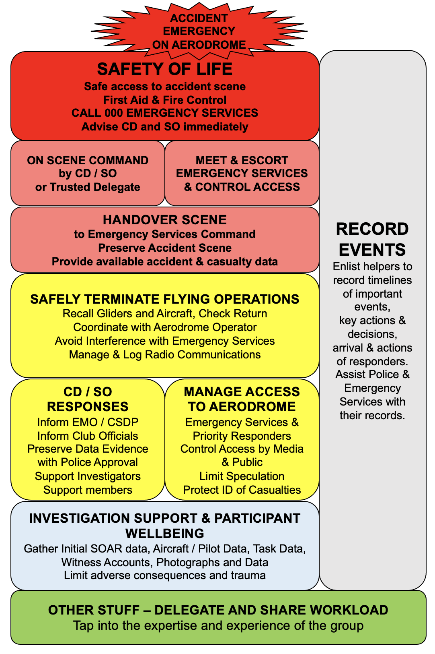

SCENARIO 2 – ACCIDENT ON TASK REMOTE FROM AERODROME

ERP - IMMEDIATE PRIORITIES AND RESPONSES

1. SAFETY OF LIFE
- Gather information on nature of accident, location, aircraft involved
- Call Emergency Services (000) – Police, Fire, Ambulance
- Call AUSSAR (1800 815 257)
- Ascertain if other pilots able to provide immediate accident site support, first aid, communications.
- Only if required to prevent further injury, remove to safe location clear of immediate hazards, with extreme care. Removal of hazards may be necessary to avoid further injuries.
- Inform CD and SO – responsible for safety and event management.

2. ASSIST EMERGENCY SERVICES
- Establish on scene command and communications relay until Emergency Services arrive on scene.
- Support Emergency Services rapid access to the accident site and any deceased or injured people.
- Provide handover advice to Emergency Services Command, provide relevant information and safety advice.
- When practicable, send support team to accident site to assist authorities.
- Provide advice on preserving the accident scene and important evidence.
- Note: If there is a fatality, the crash site technically becomes a crime scene.
- Police will require strict access controls. Observe Police instructions.

3. ENSURE SAFE TERMINATION OF FLYING OPERATIONS
- Recall airborne aircraft and gliders.
- Maintain radio log and safe return log.
- Manage radio communications and safe ground operations.
- Terminate ground operations without interference to emergency response.
- Coordinate actions with Aerodrome Operator, if required.

NOTES -
- Immediate priority responses take precedence over lower priority responses described below.
- When an accident or serious incident occurs, people will be stressed and react instinctively, sometimes focusing on lower priority issues.
- Restoring a sense of calm and discipline is very important.
People will respond positively to calm and assured leadership.
Deliberate actions will usually achieve better and faster responses.
- Clear delegation of tasks to individuals is very important.
- Record keeping and photography is important.
- Seek advice. It is ok to tap into others expertise and experience.

EMERGENCY REPONSE FLOWCHART
SCENARIO 2 – ACCIDENT ON TASK / OPS AREA REMOTE FROM AERODROME
(Emergency Response for Visual Thinkers)

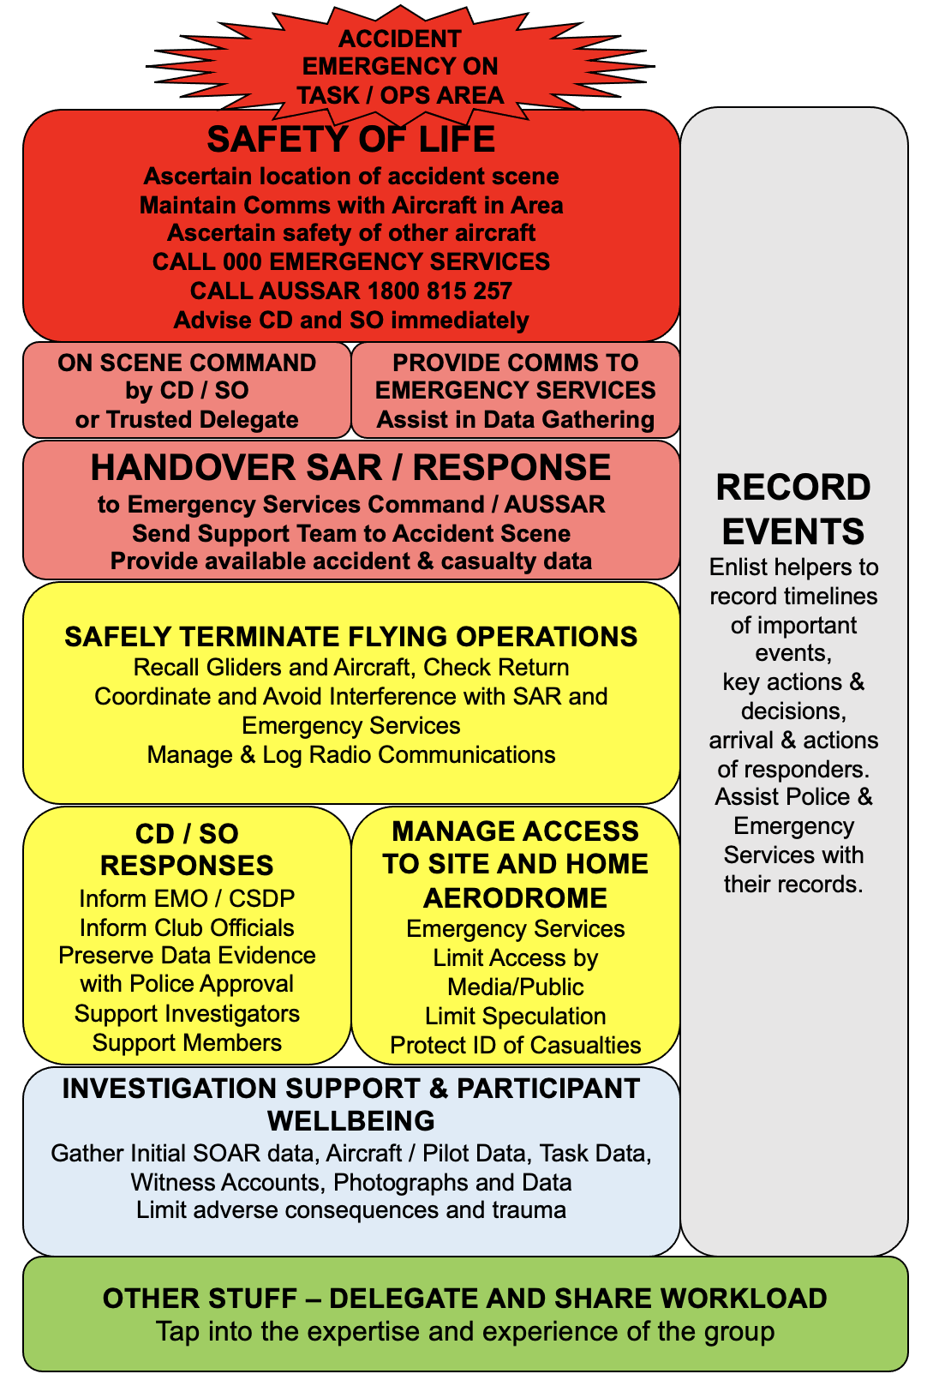

SCENARIO 3 – MISSING AIRCRAFT / SAILPLANE

ERP - IMMEDIATE PRIORITIES AND RESPONSES

1. SAFETY OF LIFE
- Gather information on aircraft / sailplane(s) involved, last known position
- Verify aircraft, sailplane, pilot not returned
- Gather aircraft data, pilot data, task data, position/time info, weather data and possible diversions
- Call Emergency Services (000) – Police, Fire, Ambulance
- Call AUSSAR (1800 815 257)
- Ascertain if other pilots able to provide immediate SAR support, relay communications.
- Inform CD and SO – responsible for safety and event management.

2. ASSIST EMERGENCY SERVICES
- Establish on scene command and communications relay until Emergency Services / AUSSAR arrive on scene.
- Support Emergency Services rapid access to information.
- Provide handover advice to Emergency Services Command, provide relevant information and safety advice.
- When practicable, assist SAR authorities in airborne and ground searches, communications watch.
- Observe Police instructions.

3. ENSURE SAFE TERMINATION OF FLYING OPERATIONS
- Recall airborne aircraft and gliders.
- Maintain radio log and safe return log.
- Manage radio communications and safe ground operations.
- Terminate ground operations without interference to emergency response.
- Coordinate actions with Aerodrome Operator, if required.

NOTES -
- Immediate priority responses take precedence over lower priority responses described below.
- When an accident or serious incident occurs, people will be stressed and react instinctively, sometimes focusing on lower priority issues.
- Restoring a sense of calm and discipline is very important.
People will respond positively to calm and assured leadership.
Deliberate actions will usually achieve better and faster responses.
- Clear delegation of tasks to individuals is very important.
- Record keeping and photography is important.
- Seek advice. It is ok to tap into others expertise and experience.

EMERGENCY REPONSE FLOWCHART
SCENARIO 3 – MISSING OR OVERDUE AIRCRAFT / SAILPLANE
(Emergency Response for Visual Thinkers)
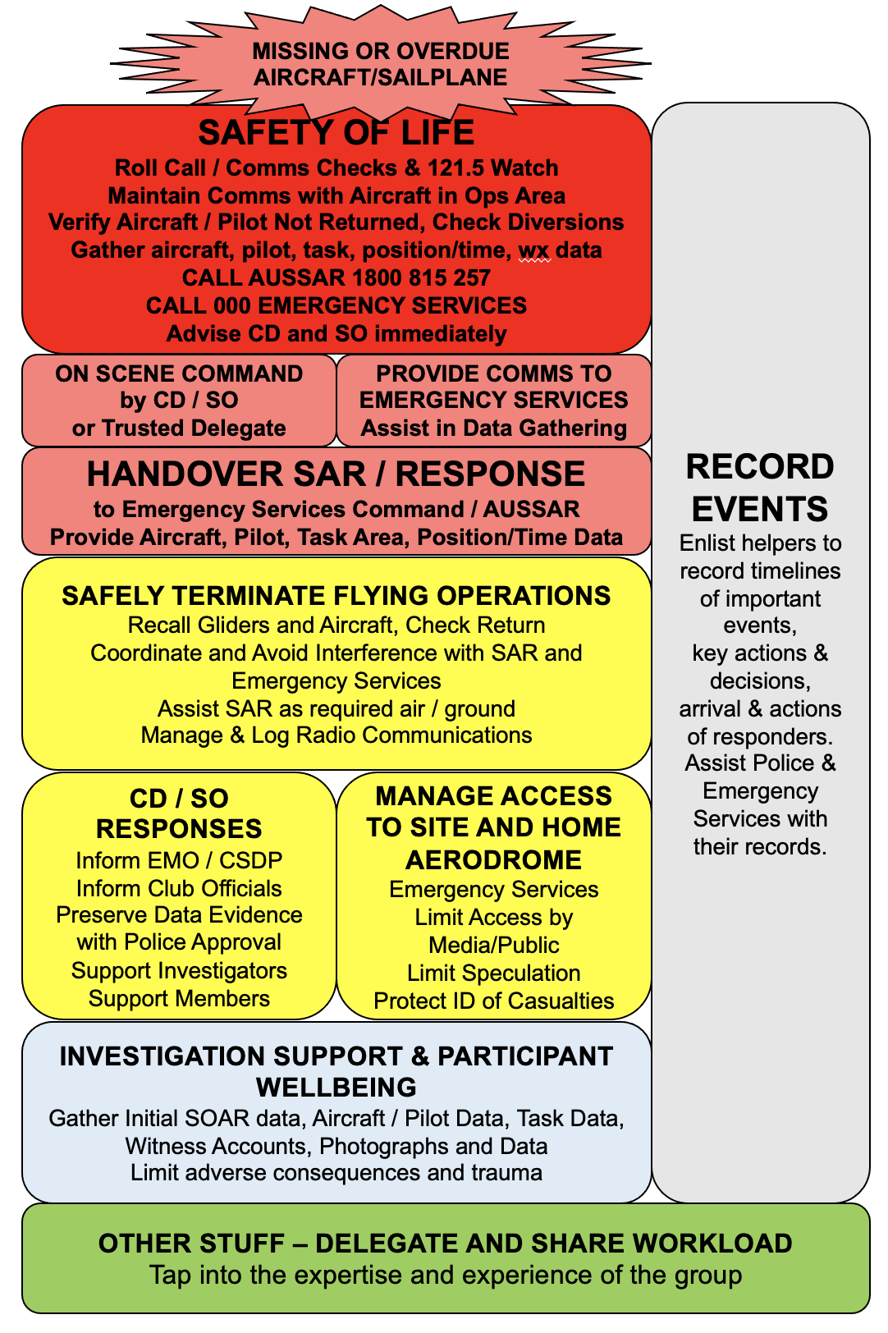

HIGH PRIORITIES AND RESPONSES

Having ensured that the immediate priorities and responses are being or have been undertaken, the following high priority actions should be pursued.
Note: If there is a fatality, the aerodrome will be closed, and the crash site is a crime scene. Police will require strict access controls.

Refer to Emergency Contact List.
If fatality or serious injury, or missing aircraft / sailplane(s), inform GFA Executive Manager Operations. EMO is primary GFA point of contact with ATSB, CASA and Emergency Authorities.

If aircraft missing, overdue or location unknown, call AUSSAR on 1800 815 257
- refer to ERP Missing Glider / Aircraft Checklist
- collect accounts of last known movements, radio transmissions
- consider using towplane and gliders airborne as SAR or radio relay assets
- ensure listening watch on distress frequency 121.5MHz
- ensure clubhouse phone and mobile numbers are monitored.
Ensure preservation of physical evidence:
- assist Police and investigation authorities
- aircraft or wreckage may have to remain in situ, if no further safety hazard
- photographs are important before any physical evidence is moved
- covering or protection of evidence may be required
Once the Police assume On-Scene Emergency Services Command, they will have the lead on collection of evidence. Ensure Police permission is sought to assist in collecting any information and evidence.

Records:
- if possible, safely save data and power down in-cockpit devices to retain relevant data and imagery as soon as possible
- assist in safe removal of batteries and devices, as required
- assist in collecting independent written statements from witnesses and those attending the scene, having briefed them on the importance of recording their own observations and actions, with minimum discussion with others –
Witness Statement Pro Forma is attached
- take and retain photographs
- take measurements and prepare diagrams
- retain meteorological forecast printouts and data

Note: If Police officers retain any records and documents, recommend delegating someone to accompany officers to the station to collect electronic copies of those documents, and retrieve data from electronic devices and loggers.

Note: Physical evidence may be collected by Police or other authorities. If this occurs, keep an inventory of what evidence is collected.

Manage members of public, limit access
- Safety of public present on the field is paramount
- Members of the public who are witnesses should be carefully debriefed and contact information retained for follow-on contact
- Delegate a club member to limit access to essential people only, politely decline or limit spectator access, provide priority access for duty crew and emergency services to manage the scene.
- Explain the necessity to reduce movement of physical evidence, limit exposure to hazards, and better manage stress or trauma of those affected
- If there is a fatality, media and public should be advised it is a Coronial issue under investigation by the Police. The airfield will be closed as a crime scene. Police will require strict access controls.

Manage media access or inquiries, limit uninformed public comment
- If media are present, ensure they are escorted by a club member at all times and refer them to duty instructor
- Defer comment to club officials, the designated club Point of Contact
- If time permits, draft a very short statement of the key facts regarding the accident or incident, offer a statement at an appropriate time and setting
- Avoid speculation. Everything is on the record.
- If there is a fatality, DO NOT release names of victims, media and public should be advised it is a Coronial issue under investigation by the Police
- Refer to OAN 03/12(1) The Media and Gliding Accidents Revision 1 dated 6th July 2022

Manage club members / participants present on the field
- Focus on key facts, maintain confidentiality of sensitive information including names of any fatalities, avoid or limit speculation
- Affirm assistance will be provided to deal with any stress or trauma
- Affirm that it is normal for strong emotions to be felt, that may require expression and comfort
- Request statements in writing from members present as to what they did or did not see, what their actions were
- Get a complete list of members present and contact information

NOTES:
- These responses are important, at lower precedence than Immediate Priorities and Responses.
- When an accident or serious incident occurs, people will be stressed and react instinctively, sometimes focusing on lower priority issues.
- Restoring a sense of calm and discipline is very important.
People will respond positively to calm and assured leadership.
Deliberate actions will usually achieve better and faster responses.
- Clear delegation of tasks to individuals is very important.
- Record keeping and photography is important, with Police permission.
- Seek advice. It is ok to tap into others expertise and experience.
- Clear delegation of tasks to individuals is very important, noting that many activities here must occur in parallel.
- If there is a fatality, Police officers will have authority over many issues on the airfield, but as non-aviators will require expert advice and counsel on what actions are appropriate. The duty instructor must therefore establish a direct clear relationship with the Police officer-in-charge on the scene. The airfield must be closed, and access controlled.

FOLLOW-ON RESPONSES

The follow-on priorities and responses will be unique to each event.
This checklist should be used for guidance and allocation of lead responsibilities.
These actions and considerations are not in any order of precedence.

- Provide counseling and support for stress or trauma, support to families
- Hot Debrief” – as soon as possible hold a debrief of all participants

- Prepare a briefing for Competition / Event Director and Safety Officer use
- Submit initial SOAR report (within 24hrs for ATSB notifiable fatal or serious accident)
- Initial accident summary with Event Safety Committee, provide assistance to appointed investigators
- Manage insurance claims

- Maintain liaison with Police, Coroner, EMO, on provision of data and evidence
- Meet to capture lessons, changes to Club Safety Management System, Event Emergency Response Plan and resources for support teams

- Manage reputation and media contacts, local community relations
- Provide support to club office bearers

- Holler if you need help!

Competition/Event Emergency Contact Numbers
Current at [insert date]

Emergency Phone - 000 | Be prepared to provide information as follows:  1. Who you are - Include Contact phone number  2. Where you are (Airfield Location & Access)  3. Situation - Emergency description  4. Required Response
Local Police -
Be prepared to stay online to assist emergency responders
Emergency Radio Frequency: 121.5 MHz |  | Local Area Frequency: MHz
GFA Executive Manager Operations (EMO)  Primary Contact with ATSB & Emergency Authorities |  |  | 0414 476 151  emo@glidingaustralia.org
Competiton / Event Director
Coordination and Management of Organisation
Competition / Event Safety Officer (SO)
Primary Contact on Emergency Response
Club CFI / Panel Chair
Primary Club Operations Contact
GFA Chair Soaring Development  Competition Management Advice |  |  | 0417 629 782  csdp@glidingaustralia.org
GFA Safety Manager (SM)  ERP Response & Support Advice |  |  | 0447 655 717  safety@glidingaustralia.org
Additional Emergency Phone Contacts
Local Police Station
Local Ambulance Service
Local Fire Service
ATSB Hotline (Reportable accidents and incidents) | 1800 011 034
Rescue Coordination Centre Australia  (SAR, lost or overdue aircraft) | 1800 815 257
Tugmaster
Club President
Regional Manager Operations (RMO)
Regional Manager Airworthiness (RTOA)
https://glidingaustralia.org/emergency-contact/ [Add Club website address]

RECORD OF EVENTS, ISSUES, DECISIONS, ACTIONS, KEY FACTS, CONTACT INFO

_{Date Time} | _{Persons} | Event / Issue / Decision / Action / Description

Completed By:…………………………Date/Time:……………Phone / Email………………………..
Page ___ of ___

AIRCRAFT / GLIDER MISSING OR OVERDUE CHECKLIST
- Assess Overdue Report
Is glider or aircraft overdue or not accounted for?
Most overdue reports are due to lack of communication between pilot and other members.
- Check and record last contact information
  - Aircraft airborne / TP data / Tracker data
  - With Club Members
  - Car Park
  - Trailer Park
- Collect the following for AusSAR - Rescue Coordination Centre and GFA EMO
(AusSAR 1800 815 257) (GFA EMO 0414 476 151)

Sailplane 1 Call Sign, Comp Markings and Type
– colour, markings, photo

Number of people on board:
Name, Age, Mobile phone
Name, Age, Mobile phone
Sailplane 2 Call Sign, Comp Markings and Type
– colour, markings, photo

Number of people on board:
Name, Age, Mobile phone
Name, Age, Mobile phone
Point of Departure

Time of Departure

Task, Turnpoints, Ops Area

Last Known Position, time and how derived.

Survival and communications equipment carried (including GPS, trackers, EPIRBs, EC/ADS-B)

Weather at the time of the report
Possible Diversions / Alternates / Outlandings

Aircraft airborne in area and SAR assets deployed
AusSAR will manage the incident, however the club will be required to maintain open lines of communication to verify information and enable search planning and progress.
- Notifications - Refer to Emergency Contact List - Important - Record Date Time Contact Log
Date Time | Who Contacted | Details / Information

EMERGENCY RESPONSE WITNESS REPORT LIST

Incident………………………………………….. Date …………………… Time ………………
List of involved parties and witnesses requested to provide written witness reports

Witness Name | Phone | Email | Address
Witness Coordinator …………………………… Phone………………………………
Email……………………………….

EMERGENCY INCIDENT WITNESS STATEMENT

Involved parties and witnesses are requested to write a statement of facts and recollections
as soon as possible after the event to assist with investigations.
Please add extra pages, diagrams, photographs as necessary.
Please describe data you may be able to download and provide later.
If possible, please provide this statement to on-scene Commander or investigator prior to leaving the scene.
[Relevant Information may include Location, time, what seen, persons involved, aircraft involved, accident description, consequences, immediate actions, responses, decisions, follow-on actions, description of effects of actions, persons informed, immediate investigations, etc.
Diagrams may be added on reverse. Any electronic device data should be described and made available to investigators.
NOTE: Investigators will pursue causal factors, sequence of events.
Your focus on facts and direct observations will be most useful.]
[Add additional text, maps and diagrams on reverse, or additional pages as necessary]

Witness Name | Witness Address | Witness Phone & Email

Signed Date / Time
Witness Diagrams

POST-EVENT EMERGENCY RESPONSE REVIEW CHECKLIST

Lessons on Emergency Response from Accidents & Incidents since last competition or event

Significant safety decisions and changes since last competition or event

Other ERP change issues

Significant Hazards / Risk Factors in Current Environment, Risk Mitigation Intentions

Competition Director

Safety Officer

Host Club CFI

Current ERP Version ____________________ Date Reviewed / Issued ________________

